System Requirement
Specification

for

BISSON HEALTH
DISEASE RESOURCE CENTRE

Expected Deliverables
The following Deliverables are expected to be produced after successful completion of the project:
- Bisson Health Disease Resource Centre (DRC) – Web Version
- Bisson Health Disease Resource Centre (DRC) – Mobile App Version (iOS, Android)
- Bisson Health – Mobile App Version (iOS, Android)

A diagram showing the possible modules required for:
- Bisson Health Disease Resource Centre
- Bisson Health Disease Resource Centre (Hidden Interface)
- Bisson Health App

These modules have been colour coded to represent three phases of development:
- Phase 1 (Green) – Development of base modules for patient and device data management
- Phase 1.5 (Red) – Development of base modules for professional and device data management
- Phase 2 (Blue) – Development of advanced modules for professional users and patient support

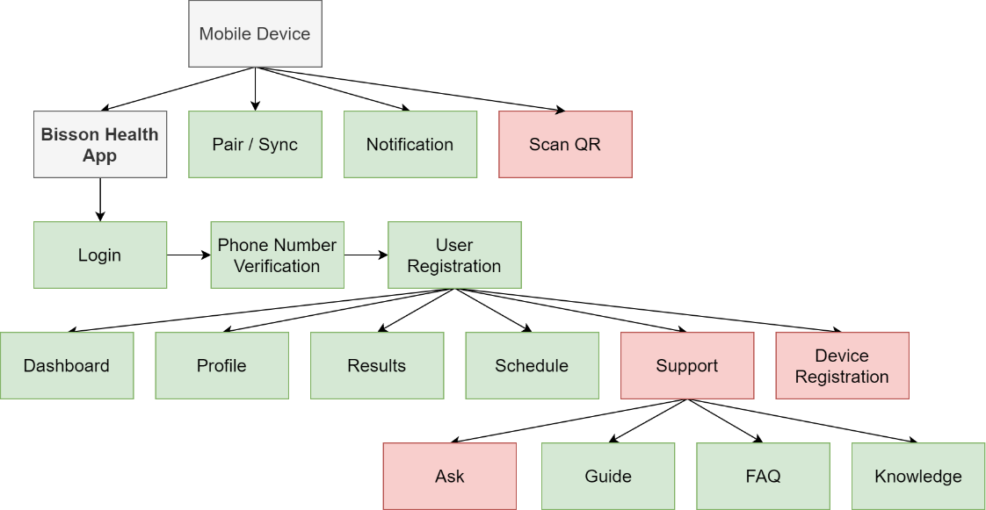

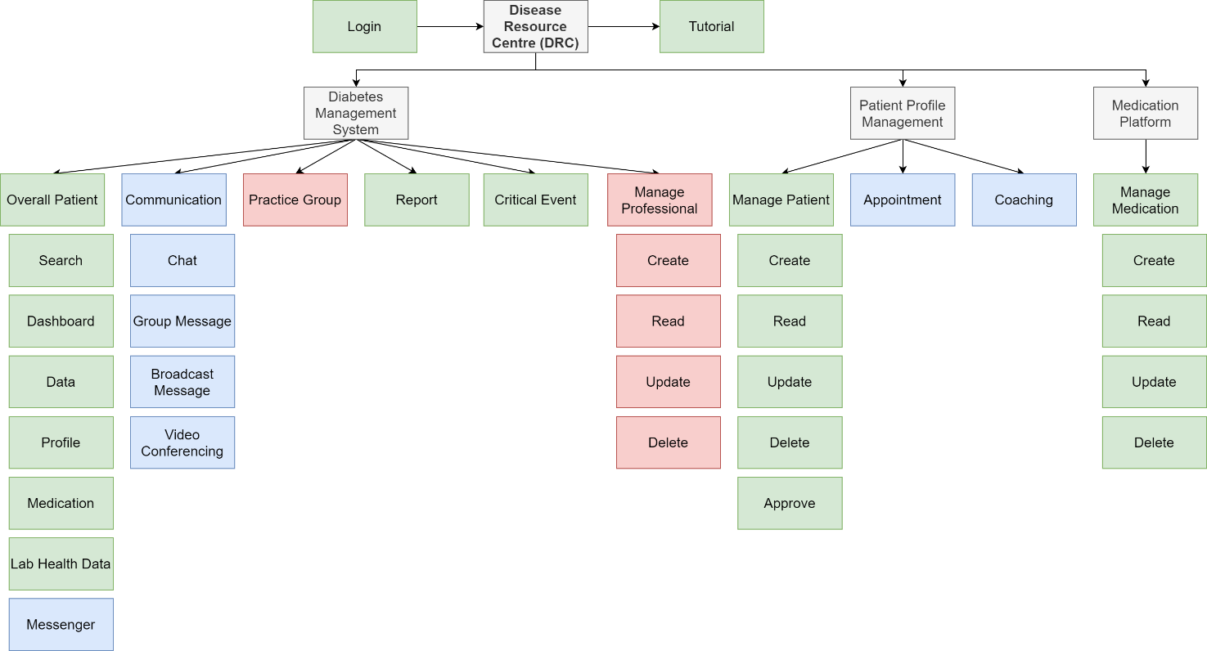

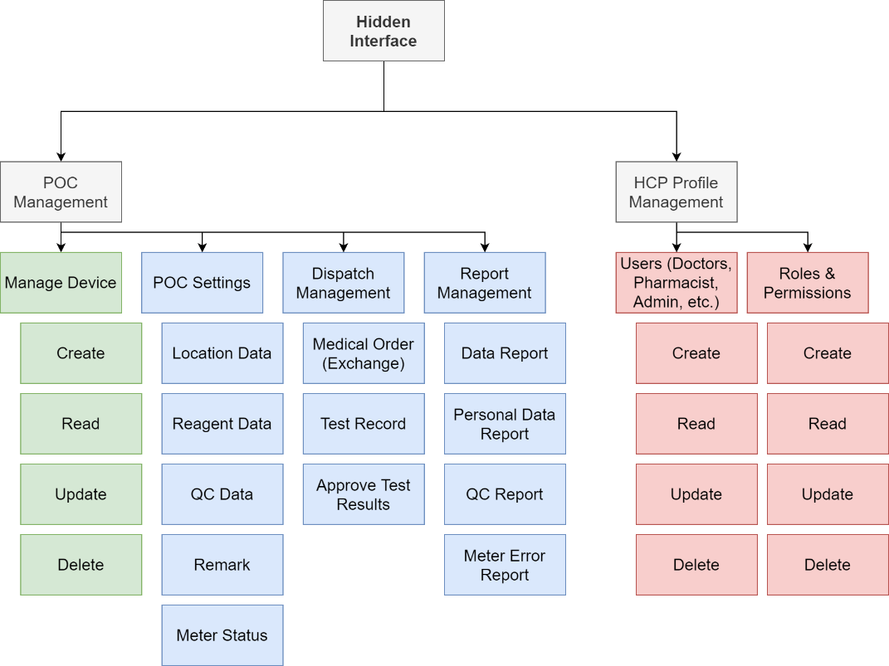

BISSON HEALTH APP (Mobile Version for patients)
Module | User Needs | Functionalities
Login  register | Register for an account | - Select country  - Enter mobile phone number  - Accept terms and conditions  - System sends out SMS verification code  - Enter SMS verification code  - Enter name, gender, DOB  - Register
 | Login using mobile number | - Select country  - Enter mobile phone number  - Accept terms and conditions  - System sends out SMS verification code  - Enter SMS verification code  - Login
Device pairing | Manage Bluetooth devices | - View all paired devices  - Add and search a Bluetooth device  - Pair a Bluetooth meter  - Accept Bluetooth device pairing request  - Sync a Bluetooth meter with APP  - Unpair a Bluetooth meter  - Remove a Bluetooth meter
Health data entry  [BG: Blood Glucose]  [BP: Blood Pressure] | Enter health data manually | - Add BG data  - BG level mmol/L  - Date and time  - Period: Wake up, Before Breakfast, After Breakfast, Before Lunch, After Lunch, Before Dinner, After Dinner, Bedtime, Midnight  - Add Note:  - Photo (Camera, Library)  - Carb intake (g)  - Insulin dose (Rapid acting, Long Acting, Premix, Immediate Acting)  - Exercise duration: Yoga, Walking, Cycling, Lifting, Swimming, Jogging, Aerobic (hr: min)
- Add BP data:
  - Systolic blood pressure (mmHg)
  - Diastolic blood pressure (mmHg)
  - Pulse (bpm)
  - Date and time
 | Auto sync new health data | - Tap to sync BG device to App:  - Display BG level mmol/L, Date and time, Period  - Check option: Edit Period, Add note  - *Cannot delete BG reading
- Tap to sync BP device to App:
  - Display SBP/DBP (mmHg), Pulse, Date and time
  - Retest, save
  - *Cannot delete BP reading
Dashboard | View diabetes summary statistics | - View BG summary statistics:  - 7-, 14-, 30- and 90-day records  - Percentages of Hypo, Good, Hyper events  - Between periods records  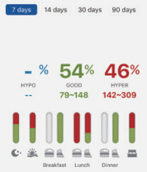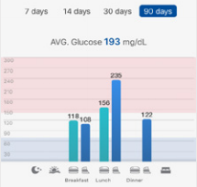  (*percentages of hypo, good and hyper levels and average glucose level are calculated using readings taken over the past 7,-, 14-, 30- and 90 days; the bar charts further categorized the percentages and average BG levels by period)
Data analytics | Manage BG records in different formats | - Display BG records:  - List view  - Between-meals view  - Edit period of a BG record  - Edit / add note to a BG record  - Display average glucose level  - Indicate Hyperglycaemic event  - Indicate Hypoglycaemic event
 | View HbA1c records | - Display HbA1c record (%)  - HbA1c > 7% (critical)  - Date and time
 | View BP records | - Display average SBP/DBP (mmHg)  - Display average pulse (bpm)  - Display BP historical records  - Date and time
Profile | Manage personal details | - Edit profile:  - Photo  - Mobile Number (change and verify)  - Name  - DOB  - Gender  - Height (ft.in/cm)  - Weight (lbs/kg)  - Unit of Measurement (English/Metric)  - Display QR code (for Identification)  - View connections with CARE Team (Added by Admin only)
 | Manage BG Goal Range | - Select diabetes type  - Set BG Goal Range (*will affect glucose statistics calculation)  - Before meal  - 2 hrs after meal  - Bedtime  - Set HbA1c level (%)  - Display measurement unit
 | Manage Daily Testing Schedule | - Plan weekly testing schedule:  - Day: Monday – Sunday  - Period: Wake up, Breakfast, Lunch, Dinner, Bedtime  - Activate / deactivate testing reminder  - Wake up, Before Meal, After Meal, Bedtime
Support (Messenger) | Manage communications with CARE Teams | - Authorize a CARE Team  - Choose a CARE Team  - System sends out SMS verification code  - Enter SMS verification code  - Authorize  - Message a CARE Team that they have been assigned to by professionals  - View chat history with a CARE Team  - Deauthorize a CARE Team  - Choose a CARE Team  - System sends out SMS verification code  - Enter SMS verification code  - Deauthorize  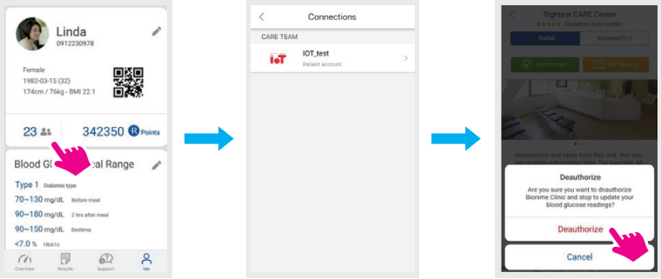
Tutorial | View tutorials | - View tutorial about the App and Bluetooth devices  - Text, image, video  - Content of tutorials
Support (Guide) | View guide | - Built-in guide for  - Information about the App  - FAQ  - View health topics
Device registration | Register Device | - Register Meter  - Select “Place of Purchase”  - Scan store QR code for warranty registration  - Confirm store of purchase and select “Register Now”  - Display Warranty information  - Product name  - Serial number  - Date of product warranty

BISSON HEALTH DRC (Web Version for Professionals)
Module | User Needs | Functionalities
Login Register | Register for an account | - For Hospital Admin, Professionals  - Get Unit code, approved ID and default password from Sales team  - For Admin, Regional Admin  - *Email
 | Login an account | - For Hospital Admin, Professionals  - Enter Unit ID and Password  - For Admin, Regional Admin  - *Email
Manage Patient | Manage Patient Account | - Create new patient account (not registered via App):  - Name  - Gender  - DOB  - Unit ID and password  - Diabetes type  - Patient no  - Advanced information (Date of diagnosis, Practice group, Mobile phone number, Attending physician, HealthCare provider)  - Add patient registered via App  - Enter mobile phone number  - Check for duplicate account  - Merge duplicate account (Name, Gender, Birthday, Phone number, 3 identical attributes)  - Add patient as member  - System sends out SMS verification code  - Enter SMS verification code  - Approve authorization
Overall Patient | View all patients and monitor patient blood glucose levels | - View all patients  - Ordered by the latest measurement upload time (cannot be deleted)  - Ordered by recent communication  - Indicate number of unread messages from patients  - Display summarised patient info: Name, Age, Mobile number, Practice Group, last health data upload time  - Select a patient to enter blood glucose monitoring page
Patient Monitoring | Monitor patient blood glucose levels | - Three tabs: Log book, health data, remark, about patient  - Log Book (Statistics, Charts, List)  - Glucose Summary Pattern  - Smart Log Book  - Daily Glucose Pattern  - Daily Period Glucose Variation  - Display estimated and real HbA1c  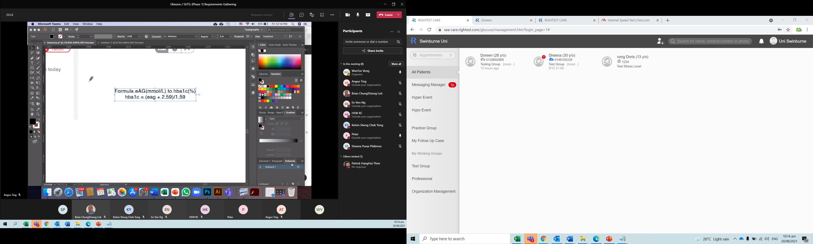  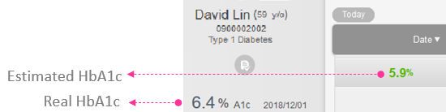  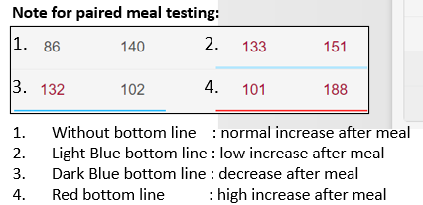  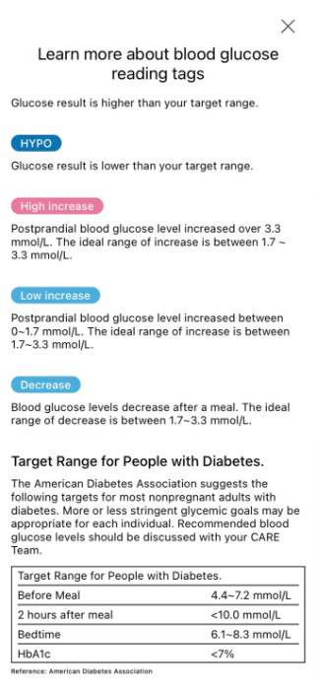  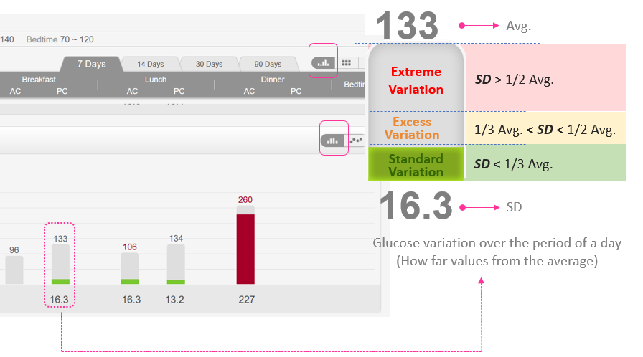  - Health Data  - Configure health data  - Add Health data (Date, Weight, BP, HbA1c, CHO, TG, LDL, HDL, eGFR, CRE, PRO)  - Only display HbA1c in Mobile Health App  - Remark  - Write notes about patient information and medicine record  - About Patient  - Set patient’s personal BG target range: AC, PC, Bedtime, HbA1c)  - Testing plan
Critical Event | Manage Hyper and Hypo events | - General BG target range  - Set / modify target range  - View historical records: 1-, 3-, 7-, 14-day  - Display summarised patient info  - Sort patients by period  - Sort patients by Hyper / Hypo percentage (%)
- Patient’s personal target range
  - Set / modify target range
  - View historical records: 1-, 3-, 7-, 14-day
  - Display summarised patient info
  - Sort patients by period
  - Sort patients by Hyper / Hypo percentage (%)
Manage Device | Collect BG Data from Patient’s meter | - Collect data from patient’s meter (for BG only?)  - Search meter  - Pair meter  - Collect data
Manage Medication | Manage patient’s medication history | - Add, edit, and view patient’s medication history  - Active medication (oral, injectable)  - Medication schedule  - Important notes  - Medical history/records (EMR)  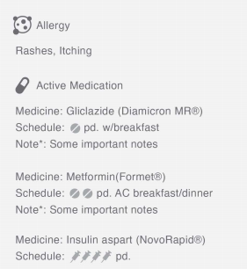  +
Tutorial | View tutorials  (for professionals) | - View tutorial about the App and Bluetooth devices  - Text, image, video  - Content of tutorials?
Report | Generate statistics reports | - Generate statistics reports (PDF, CVS)  - List of patients  - List of devices  - List of hypo/hyper events  - Etc.
Practice Group | Manage patients by practice group | - Create new practice group  - Title  - Subtitle (optional)  - Set critical glucose range: dangerously high, dangerously low in mg/DL  - Select add, or remove patients from a practice group  - Select, add, or remove staff from a practice group  - Display practice group information  - Title, subtitle, number of professionals and patients in the group, average BG level, number/percentage of patients that happen with hypo and hyper glucose in a day  - Manage patients in a practice group  - Assign a number to each patient  - Display patient information (Name, Age, Phone number, join date, BG level)  - Display BG range of patients (Dangerously low or dangerously high based on personal target range)  - BG level over/below personal target range (display in red/blue background)  - Default setting <70 Dangerously low, >250 Dangerously high  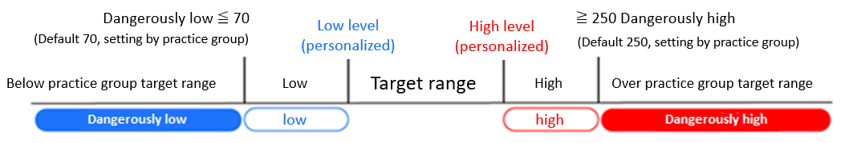  - Edit practice group information  - Delete a practice group  - Generate report for selected patients and selected time range (PDF, Excel, CSV)
Manage User | Manage professional account | - Create professional account  - Enter name  - Select gender  - Select country  - Enter mobile phone number  - Enter Login ID and password  - Select Type of Profession  - Edit personal information  - Edit working group (=practice group?) information  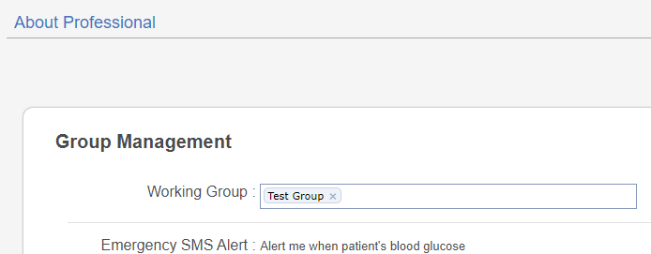  - Set to receive emergency SMS when patient’s reading is below or over the range​
Roles & Permissions | Manage roles and permissions | - Add roles  - System Admin  - Regional Admin  - Hospital Admin  - Professional  - Add, edit or delete permissions
Appointment | Manage appointment with patients? | - Display number of patients waiting to see doctor after “POCT” testing  - Doc2us (appointment, e-prescription)
Communication | Manage recent communication with patients | - Badges to indicate unread messages  - View recent messages in chat room  - Badges to indicate unread notes  - View recent notes (photo carbohydrate, exercise records) uploaded by patients
Coaching | Educating professionals? | 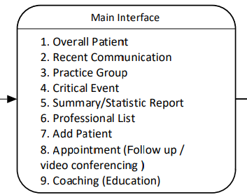
POC Settings |  | - Location setting  - Meter setting  - Reagent setting  - QC setting  - Remark setting  - Meter status  - POC Settings
Dispatch Management |  | - Medical Order (Exchange)  - Test Record  - Approve Test Results
Report Management |  | - Data report  - Personal Data Report  - QC Report  - Meter Error Report

BISSON HEALTH DRC (Mobile Version for Professionals)
Module | User Needs | Functionalities
Login | Log in an account | - Hospital admin  - Enter Unit ID and password, or  - Scan QR code  - Medical professional  - Enter Unit ID and password, or  - Scan QR code
Patient List management | Overall patients | - View all patients  - List view  - Grid view  - Search Patient  - Enter patient name, or  - Scan QR code
 | Manage patient account | - Create new patient account  - Enter Name, Patient number (ID), DOB, Gender, Type of diabetes, Mobile Number, Care Area, Year diagnosed, Emergency contact  - Create account
 | Manage patient profile | - Edit patient personal information  - Name, DOB, Gender, Mobile number,  - Set patient’s personal target range  - Type of diabetes, HbA1c (%), AC, PC, Bedtime (mg/dL)  - Display connected Practice Group & professionals  - Add & remove Bluetooth devices
 | Patient monitoring | - View BG summary statistics:  - Readings in list view or form view  - 7-, 14-, 30- and 90-day records  - Percentage of Hypo, Good, Hyper events  - Between periods records  - Average BG level  - Display estimated and real HbA1c  - View Biomarkers records:  - Date, Time, Weight, BP, HbA1c, CHO, TG, LDL, HDL, eGFR, CRE, PRO)  - Remark  - View / Write notes about patient information and medicine record
 | Collect Health Data | - Enter Biomarkers manually  - Date, Time, Weight, BP, HbA1c, CHO, TG, LDL, HDL, eGFR, CRE, PRO)  - Collect data from patient’s meter  - Search meter  - Select paired meter  - Sync data  